
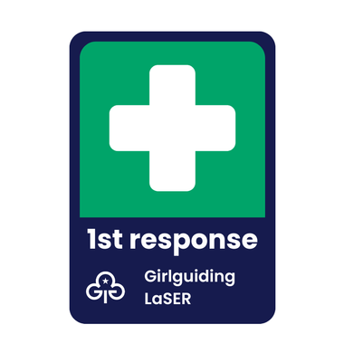
First Response Training 2025

To all volunteers in Middlesex West
There is one last opportunity to ensure that your 1st Response qualification is current for 2025 at Galbraith Hall. It is advisable that all adult volunteers have a 1st Response qualification and there must be at least one adult present at every meeting of your unit with this qualification.
When it comes to residentials, camps and trips the identified First Aiders must hold an acceptable and current 1st Aid qualification.
The last Galbraith Hall 1st Response training opportunity will be held on Saturday 4th October 2025 at Galbraith Hall, Allenby Road, Southall, UB1 2HX. Galbraith Hall can be found on the same site as Allenby Primary School. You should park within the gates and as you approach the inner school gates Galbraith Hall is the building on the left. It is important to use the postcode and not Google Galbraith Hall as the one that comes up is in Uxbridge and we are in Southall.
Timings 9.15am to 3.30pm.
Cost £10.00 to be paid on the day.
Guide wear should be worn.
Bring a packed lunch and drink.
Bookings are taken on a 1st come 1st served basis.
To book, please complete the attached booking form and send it electronically to Jennifer Dudley – jennifer.dudley62@hotmail.com
I will email you to confirm you have a place

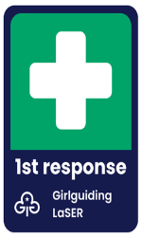 First Response Training 

Name……………………………………………….…………………………….…… Membership Number:………………….…………..
of ……………..………………………………………………………………………..(unit) would like to attend the 1st Response training on Saturday 4th October 2025 at Galbraith Hall, Allenby Road, Southall, UB1 2HX.
Contact details are: Tel: ……………………………………………………….……….
Email address: ………………………………..………………………………………..……….………
The Payment of £10 is payable on arrival or by post you should fail to attend. The amount can be paid in cash or a cheque made payable Girlguiding MW. Important to note his is a valid expense to the unit
Return this form electronically to Jennifer Dudley – jennifer.dudley62@hotmail.com

