County Skills Builder Day at Galbraith Hall 8th March

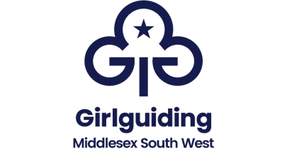
Saturday
8th March 2025

Unit Name_________________________________ (where a leader runs multiple units a separate booking form is needed for each unit)
Leader(s) accompanying _________________________________________
Name of Home Contact __________________________________________
Squash and water will be available to members attending these sessions
Stage 2 & 3  Young Member’s Name |  | Do they have Live Smart 2 or 3 already – if so, which do they have
Total Number of young members attending
Payment Details Options BACS payment Girlguiding Middlesex South West
Account Number 81419005 Sort code 402122 For reference Live Smart Day
Or Cheque Payment to Girlguiding Middlesex South-West. ALL PAYMENTS SHOULD BE RECEIVED NO LATER THAN 28th February 2025.
Please note numbers are limited and will be done on a 1st come 1st served basis. Booking forms & confirmation of payment should be returned to Jennifer Dudley-County Commissioner no later than 28th February 2025

